Republic of the Philippines

National Police Commission

Philippine National Police

**Cavite Police Provincial Office**

**CARMONA MUNICIPAL POLICE STATION**

Brgy Maduya, Carmona, Cavite

***carmonacavitepnp@gmail.com***

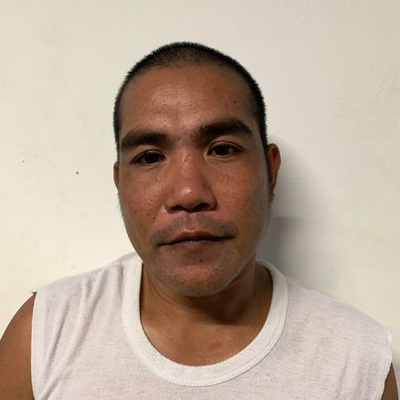

April 5, 2022

**CERTIFICATE OF DETENTION**

**TO WHOM IT MAY CONCERN**

**THIS IS TO CERTIFY** that one **ETCHEL ESPEJO BINALLA**, male, 39 years old, born on **May 19, 1982**, single, resident of **B4 L52 Brgy. Maderan, GMA, Cavite** was detained at this office since February 26, 2022 up to present and charged for the crime of **“Rape under Art. 66-A, par. (1) of the RPC and Rape through Sexual Assult under Art. 266-A par. (2) of the RPC”** with Criminal Case Nr. **CAR-2022-124 & 125,** before the Office of Provincial Prosecutor, Imus, Cavite.

This certification is being issued upon request of interested party for whatever legal purposes it may serve.

Prepared by :

Etchel Binalla, **PSSg Anderson A Videña**

Detainee Custodial Officer